LOGISTICS NOTE
Vienna Food Safety Forum 2022
“Data-driven innovation on Food Safety”
AUGUST 2022

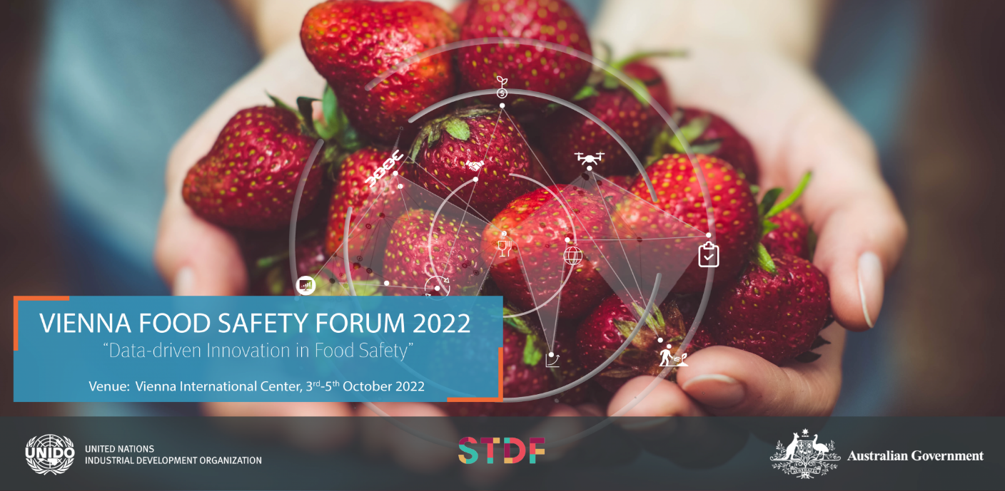

Contents

1. Venue 2
2. Language requirements and documentation 2
3. Participation 2
4. Administrative and Financial arrangements 2
5. List of hotels 3
6. How to get to the Vienna International Centre 9

- Venue
The Vienna Food Safety forum will take place in Vienna, Austria, at the headquarters of the United Nations Industrial Development Organization (UNIDO), Vienna International Centre (VIC), Board Room 04, C-Building. The forum will be also accessible virtually.

- Language requirements and documentation
The working language of the event will be English. Simultaneous interpretation will be available in the following languages: English, French, and Spanish. All documentation and background materials will be provided in these languages as well.

- Participation
The event will gather high-level government representatives, institutional stakeholders, development partners, academia, regulators and business sector entities. In particular:
- Food safety regulatory authorities
- International Organizations
- Private sector representatives from food industry
- Members of the Global Food Safety entities
- International experts in food safety

- Administrative arrangements
Visas
Prior to leaving their home country, participants are requested to make their own arrangements for any entry visas or travel permits that may be required for the entire travel (including for transit countries) to Vienna. A letter of assistance from UNIDO to facilitate the issuance of visas could be provided upon request.
Registration procedure:
Participants are requested to register online for the Vienna Food Safety Forum via the link below:
https://www.eventbrite.de/cc/vienna-food-safety-forum-2022-832689

- List of hotels
Hotel Ambassador******
In the centre of Vienna, underground U1/Stephansplatz
Address: Neuer Markt 5, 1010 Vienna
Tel: (43-1) 961610
Email: office@ambassador.at

The Ring****
U1/Karlsplatz
Address: Kärntner Ring 8, 1010 Vienna
Tel: +(43-1) 515801818 or 1819,
Email: vbukovics@jjwhotels.com

Holiday Inn Vienna South****
Address: Business Park Vienna, Hertha-Firnberg-Strasse 5, A-1100 Vienna
Tel: +(431) 60530
E-mail: hivienna@whgeu.com

Hotel am Opernring ****
Address: Opernring 11, 1010 Vienna
Tel: +(431) 5875518
e-mail: hotel@opernring.at

Hotel Anatol ***
U3 Zieglergasse
Address: Webgasse 26, 1060 Vienna
Tel: +(43-1)59996-0
e-mail: reservierung.anatol@austria-trend.at

Hotel Astoria ****
Near U4 and U1, few stops from VIC
Kärntner Strasse 32, 1010 Vienna
Tel: (43-1)51577-88
e-mail: reservierung.astoria@austria-trend.at

Hotel Europa Wien****
U1 Stephansplatz
Address: Kärntner Strasse 18
Tel: (43-1)51577-300
e-mail: reservierung.europa.wien@austria-trend.at

Hilton Vienna Danube Waterfront*****
Few stops with the underground and free shuttle service to VIC every morning
Address: Handelskai 269, 1020 Vienna
Tel: (43-1) 727 77-70000, Fax: (43-1) 727 77-71000
Email: vienna.reservations@hilton.com

Hilton Vienna *****
Underground U4, Stadtpark, change to U1, few stops from VIC
Address: Am Stadtpark, 1030 Vienna
Tel: (43-1) 717 00/12304 or 14000
Fax: (43-1) 717 00/12321 or 11000
Email: vienna.reservations@hilton.com

Hilton Vienna Plaza*****
Few minutes walk to the center and underground U1
Address: Schottenring 11, 1010 Vienna
Tel: (43-1) 31 390 20000, fax: (43-1) 31 390 21000
Email: vienna.reservations@hilton.com

Hotel NH Danube City****
Few minutes walking distance from VIC, U1/Alte
Donau Address: Wagramer Strasse 21, 1220 Vienna
For reservations call: 0820 40115536
E-mail: reservierungen.at@nh-hotels.com

Ibis Wien Messe***(Accor Hotel)
U1/Vorgartenstrasse
Address: Lasallestrasse 7A, 1020 Vienna
Tel: (43-1)21770506
E-mail: h2636@accor.com, frederick.salesse@accor.com

Hotel Melia
350 m from VIC
Donau-City-Strasse 7, 1220 Wien
www.melia.com
Tel. +43 (0) 1 90 104 - 2041

Mercure Wien City **** (Accor Hotel)
U4/Schwedenplatz
Address: Hollandstrasse 3, A-1020 Wien
Tel: (43-1)213-13
e-mail: h1568-RE@accor.com

Mercure Wien Zentrum ****(Accor Hotel)
U4/Schwedenplatz
Address: Am Fleischmarkt 1a, 1010 Vienna
Tel: (43-1)534601230
E-mail: h0781-re@accor.com, frederick.salesse@accor.com

Novotel Wien City**** (Accor Hotel)
U1/Nestroyplatz
Address: Aspernbrückengasse 1, 1020 Vienna
Tel: (43-1)90303991
E-mail: h6154-re@accor.com

Hotel De France ****
In the centre close to U2 Schottentor
Address: Schottenring 3, 1010 Vienna
Tel: (43-1) 31368-3384 or 31368-7070, Fax (43-1) 31959-69
E-mail: s.kusic@austria-hotels.at

AustriaTrend Hotel Donauzentrum****
In the Shopping Centre nearby, U1/Kagran (two stops with the underground only from VIC)
Address: Wagramer Strasse 83-85, 1220 Vienna,
Tel: (43-1) 203 55 45-113, Fax: (43-1) 203 55 45-183
E-mail: reservierung.donauzentrum@austriatrend.at
Internet: www.austria-trend.at

Hotel Erzherzog Rainer****
U1/Taubstummengasse
Address: Wiedner Hauptstrasse 27-29, 1040 Vienna
Tel: (43-1) 22111, Fax: (43-1) 21150519
E-mail: rainer@schickhotels.com
Internet: www.schick-hotels.com

Hotel Capricorno****
U1/Schwedenplatz
Address: Schwedenplatz 3-4, 1010 Wien
Tel: (43-1) 533 31 04-0, Fax: (43-1) 533 76 714
E-mail: capricorno@schick-hotels.com
Internet: www.schick-hotels.com

Hotel Rathauspark****
U2 Rathaus
Address: Rathausstrasse 17, 1010 Wien
Tel: (43-1) 40412-762 reservierung.rathauspark@austria-trend.at

Hotel Stefanie****
U1/Schwedenplatz or Nestroyplatz
Address: Taborstrasse 12, 1020 Vienna
Tel. (43-1) 211 50-520, Fax (43-1) 21150-526
E-mail: stefanie@schick-hotels.com
Internet: www.schick-hotels.com

Hotel City Central****
U1/Schwedenplatz
Address: Taborstrasse 8, 1020 Vienna
Tel. (43-1) 211 05-0, Fax (43-1) 211 05-140
Email: city.central@schick-hotels.com

Hotel Am Parkring****
U3/Stubentor or U4/Stadtpark
Address: Am Parkring 12, 1015 Vienna
Tel. (43-1) 514 80-0, Fax: (43-1) 514 80-40
Email: parkring@schick-hotels.com

Parkhotel Schönbrunn
U4 Hietzing
Hietzinger Hauptstrasse 10-14 Tel: (43-1) 87804-0
reservierung.parkhotel.schoenbrunn@austria-trend.at, melanie.maurer@austriatrend.at

Radisson Blu Style Vienna*****
U3/Herrengasse,
Address: Herrengasse 12, 1010 Vienna
Tel: (43-1) 22780-0
Email: sales.Vienna@RadissonSAS.com
Internet: www.radissonblu.com

Radisson Blu Palais Hotel*****
Few steps from underground, change once to VIC
Address: Parkring 16, 1010 Vienna
Tel: (43-1) 515 17-0, Fax: (43-1) 512 22 16
E-mail:
Sales.Vienna@RadissonSAS.com
Internet: www.radissonsas.com

Hotel Marriott****
U4/Stadtpark, U3/Stubentor
Address: Parkring 12a, 1010 Vienna
Tel: (43-1) 515 18-53, Fax: (43-1) 515 18-6722
E-mail: vienna.marriott.reservations@marriotthotels.com

Hotel Sacher****
U1/Stephansplatz, U4/Karlsplatz
Address: Philharmonikerstrasse 4, 1010 Vienna
Tel. (43-1) 51 456-0, Fax: (43-1) 51456-810
E-mail: wien@sacher.com, ggressl@sacher.com, (Mr.
Gressl) Internet: www.sacher.com

Suite Novotel Wien Messe**** (Accor Hotel)
U1/Vorgartenstrasse
Address: Radingerstrasse 2, A-1020 Vienna
Tel: (43-1)245880
E-mail: h3720@accor.com, frederick.salesse@accor.com

Das Triest*****
U1/Karlsplatz
Address: Wiedner Hauptstrasse 12, 1040 Vienna
Tel. (43-1) 589 18 385
e-mail: tamara@dastriest.at

Hotel beim Theresianum ***
Close to U1 Südtiroler Platz (direct line to VIC)
Favoritenstrasse 52, 1040 Wien
Tel: (43-1)5051606
E-mail: melanie.maurer@austria-trend.at, theresianum@austria-trend.at

Austria Trend Hotel Europa Wien****
Located in the centre of Vienna, a few stops with the underground from
VIC Address: Kärtnerstrasse 18, 1010 Vienna
Tel: (43-1) 515 94-0, Fax: (43-1) 515 94-888
e-mail: melanie.maurer@austria-trend.at, europa.wien@austria-trend.at
Internet: www.austria-trend.at

Hotel InterContinental Wien*****
U4/Stadtpark
Address: Johannesgasse 28, 1037 Vienna
Tel. (43-1) 711 22-128, Fax: (43-1) 711 22-345
Email: berenike.frantsits@ihg.com
Internet: www.ihg.com

ARCOTEL Kaiserwasser ****
U1/Vienna International Centre, opposite VIC
Address: Wagramerstrasse 8, 1220 Vienna
Tel. (43-1)52165 813, Fax (43-1) 52165 810
Email: reservation.kaiserwasser@arcotel.at, Internet: www.arcotel.at/kassierwasser

Hotel am Konzerthaus ****(Accor Hotel)
U4/Stadtpark
Am Heumarkt 35-37, 1030 Vienna
Tel: (43-1)71616812
E-mail: h1276-re@accor.com, frederick.salesse@accor.com

Premium Apartments – MyPlace*****
At underground U4
Address: Rossauer Laende 23, 1090 Vienna
Tel: (43-1) 317 1717 75
Email: sales@my-place.at, Internet: www.my-place.at

Hotel Capri***
U1/Nestroyplatz
Praterstrasse 44-46, 1020 Vienna
Tel: (43-1) 214 84 04, Fax: (43-1) 214 27 85
Email: office@hotelcapri.at
Internet: www.hotelcapri.at

Austria Classic Hotel Wien***
Close to U1 Nestroyplatz or Praterstern
Address: Praterstrasse 72, 1020 Vienna
Tel: (43-1) 211 30-0, Fax: (43-1) 211 30-72
Email: info@classic-hotelwien.at
Internet: www.classic-hotelwien.at

Hotel Post***
U1 Schwedenplatz
Address: Fleischmarkt 24, 1010 Vienna
Tel: (43-1) 515 83-0, Fax: 515 83 808
Email: office@hotel-post-wien.at
Internet: www.hotel-post-wien.at

Hotel Kärntnerhof ***
U1/Stephandplatz or U1/4 Schwedenplatz
Address: Grashofgasse 4, 1010 Vienna
Tel: (43-1) 512 19 23, Fax: (43-1) 513 22 28-33
Email: info@karntnerhof.com
Internet: www.kartnerhof.com

The Levante Parliament (a member of Design Hotels)
behind the Parliament, very close to U2 station Parliament
Address: Auerspergstrasse 9, 1080 Vienna
Tel: (43-1) 5354515-50, Fax: (43-1)5354515-15
e-mail: roland.eggenhofer@thelevante.com, Internet: www.thelevante.com

Sofitel Vienna Stephansdom (Accor Hotel)
U1/Nestroyplatz
Address: Praterstrasse 1, 1020 Vienna
Tel: +(43-1)906160, www.sofitel.com/Wien
e-mail: h6599@sofitel.com, frederick.salesse@accor.com

Hotel Wandl***
In the centre of Vienna, underground U1/Stephansplatz
Address: Petersplatz 9, 1010 Vienna
Tel: (43-1) 53 455
Email: reservation@hotel-wandl.com

Hotel Lamée & Topazz
In the centre of Vienna, underground U1/Stephansplatz
Address: Lichtensteg 3, 1010 Vienna
Tel: +43 1 532 22 50 or +43 1 532 22 40
E-mail: booking@hoteltopazz.com, booking@hotellamee.com
Internet: www.hoteltopazz.com, www.hotellamee.com

Vienna Residence
Furnished apartments in Vienna for short or long-term rent
Tel: +43 1 307 2222
Email: info@viennaresidence.com
Internet: https://www.viennaresidence.com/en/vienna

Homelink
Furnished apartments in Vienna
Tel: +49 221 988 618 81
Email: felix.mentel@thehomelike.com
Internet: https://www.thehomelike.com

- How to get to the Vienna International Centre
Coming from the city center, take the underground line U1 in the direction of Leopoldau until you reach Kaisermühlen/Vienna International Centre, get out at the front exit of the station and then follow the signs to Gate 1 of the VIC, the main entrance.

The VIC is also easy to reach by car via the A22 motorway or from the city centre via the Reichsbrücke. Buses may park in the side street off Wagramer Strasse and in the car park beside Gate 2. The VIC is accessible to people with disabilities.

